
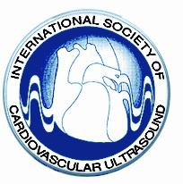



Rome, January 2007

Subject: X WORLD CONGRESS OF ECHOCARDIOGRAPHY AND CARDIOVASCULAR IMAGING
Rome Cavalieri Hilton - October 19/21, 2006

Dear Collegue,

I wish to thank you for having taken your precious time to participate as faculty in the above Congress.

The Congress was very well received by the participants in large measure due to your participation.

It is your expertise and teaching abilities which made the program a success.

I take the opportunity to ask your availability to participate to a Registry on applicat of imaging methodology for the management of different cardiovascular pathologies.
In case of positive answer, we will send you a questionnaire in the near future.

We do hope the Congress has left you with good memories.

Many thanks once again.

With best regards,

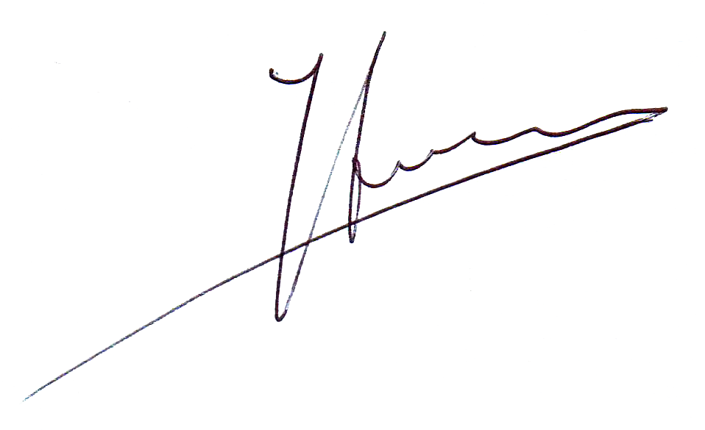
The President

Francesco Fedele

