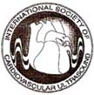
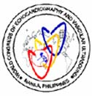
XIVth World Congress of Echocardiography,
Vascular Ultrasound and Allied Techniques
Manila, Philippines, February 17-19, 2010
under the auspices of the
International Society of Cardiovascular Ultrasound
Navin C. Nanda, MD
President, ISCU

Homobono B. Calleja, MD
President

Raul D. Jara, MD
Over-all Chairperson

Advisory Board
Adolfo B. Bellosillo, MD
Fatima R. Collado, MD
Florimond A. Garcia, MD
Edgardo E. Ortiz, MD
Jose A. Yulde, MD

Co-Chairpersons
Adoracion N. Abad, MD
Nelson S. Abelardo, MD
Maria Teresa B. Abola, MD
Marietta M. Crisostomo, MD
Lerma R. Noval, MD
Romeo J. Santos, MD
Milagros E. Yamamoto, MD
Secretary General
Norbert Lingling D. Uy, MD

Deputy Secretary General
Joel M. Abanilla, MD

Treasurer
Mariano B. Lopez, MD

Chairperson
Scientific Committee
Mary Ong-Go, MD

Co-chairperson
Scientific Committee
Eduardo S. Caguioa, MD
Ma. Lourdes S. Casas, MD
Jonas Del Rosario, MD
Ma. Ronella T. Francisco, MD
Eleanor A. Lopez, MD
Felix R. Punzalan, MD
Gregorio G. Rogelio, MD
Diana Jean C. Roxas, MD
Ricardo T. Quintos, MD
Efren R. Vicaldo, MD

Secretariat: 2/F Medical
Arts Building, Philippine Heart Center, East Avenue, Quezon City, 1100 Philippines,
Tel. # 632-9252401 Loc 3245
Fax # 632-9252401 local 3232

e

July 20, 2008

MUHAMED SARIC, MD, PhD, FACC, FASE
University of Medicine & Dentistry of New Jersey (UMDNJ)
New Jersey, USA

Dear Dr. Saric,

Greetings!
The XIV World Congress of Echocardiography, Vascular Ultrasound and Allied Techniques will be held in Manila, Philippines on February 17-19, 2010, jointly sponsored by the International Society of Cardiovascular Ultrasound (ISCU) and the Philippine Heart Association, the Philippine Society of Echocardiography and the Philippine Society of Vascular Medicine. Many prominent echocardiographers from different parts of the world will be participating to make the Congress a success.

The Organizing Committee has the honor and privilege to invite you to be a faculty member and give a talk on “Aortic Endograft Surveillance”. It would be a plus if you can also deliver “The Aging Heart: Is Impaired Relaxation Inevitable?” or a topic close to your heart in one of the Congress Sessions. The theme of this Congress is “Cardiovascular Imaging in 2010: Its Impact on Clinical Practice”.

The Organizing Committee will provide hotel accommodation for the duration of the Congress. Individual or group tours will be available. As a faculty member, the Congress registration fee will be waived.

We hope the date of our Congress is open for your travel to our country. It would be an honor for us if you could participate in this Congress.

Thank you very much and our kindest regards from the Organizing Committee.

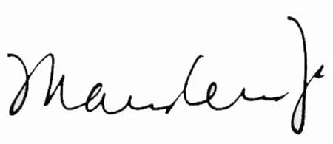
Sincerely,

MARY ONG-GO, MD RAUL D. JARA, MD
Chair, Scientific Committee Overall Chair
XIV World Congress of Echocardiography, XIV World Congress of Echocardiography,

Vascular Ultrasound & Allied Techniques Vascular Ultrasound & Allied Techniques
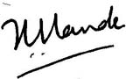

HOMOBONO B. CALLEJA, MD NAVIN C. NANDA, MD
President President, ISCU
XIV World Congress of Echocardiography, International President of the World Congress
Vascular Ultrasound & Allied Techniques

