Uncommon Doppler Echocardiographic Findings of Severe Pulmonic Insufficiency
Rahul R. Jhaveri MD; Muhamed Saric MD, PhD; Itzhak Kronzon MD
New York University Langone Medical Center, New York, NY.

Background

2-D and Doppler echocardiography are standard methods to assess the severity of pulmonic insufficiency (PI). Existing guidelines for grading PI severity rely on anatomic assessment of the pulmonic valve and right ventricle, color Doppler to determine regurgitant jet size, continuous wave Doppler to determine jet density and deceleration rate, and pulsed-wave Doppler to compare systolic pulmonic flow to systemic flow. We studied the prevalence of several Doppler echocardiographic findings of severe PI not described in the current guidelines.

Methods

We reviewed all the electronic reports of echocardiograms performed at our institution since the publication of the ASE guidelines for evaluating severity of native valvular regurgitation. In addition to traditional echocardiographic findings of severe PI documented in the guidelines, we also searched for uncommon findings of severe PI among our study patients.

Results

A total of 100,167 echocardiograms were performed over a 6-year period. There were 8,279 instances of severe valvular insufficiency among these studies. Of all forms of severe valvular insufficiency, PI was least common (125 instances of severe PI, 1.6% of all of severe valvular insufficiency) (Table 1). Holodiastolic pulmonary artery flow reversal, non-turbulent retrograde flow, premature opening of the pulmonic valve, and premature tricuspid valve closure were uncommon Doppler echocardiographic findings of severe insufficiency. Table 2 presents the frequency of these findings. Illustrative examples are shown in Figures 1-4.

Conclusion

Criteria published in recent guidelines to establish severe PI remain qualitative and do not include in detail the signs presented. These signs reflect the anatomic and physiologic features of severe PI. These include rapid blood runoff during diastole into the right ventricle that produces holodiastolic pulmonary artery flow reversal and a large effective regurgitant orifice area that produces non-turbulent regurgitant flow. Atrial contraction may increase right ventricular pressure at end-diastole causing premature pulmonic valve opening and the elevation of right ventricular pressure above right atrial pressure in diastole in severe PI may cause premature tricuspid valve closure. The criteria described above should be considered in the grading of PI severity in addition to the criteria discussed in the existing guidelines.
Table 1: Frequency of Severe Valvular Regurgitation.
 | Percent
Mitral Insufficiency | 50.5%
Tricuspid Insufficiency | 33.8%
Aortic Insufficiency | 14.0%
Pulmonic Insufficiency | 1.6%

Percentages are based on 8,279 instances of severe valvular insufficiency found among 100,167 echocardiograms.

Table 2: Frequency of Uncommon Doppler Echocardiographic Findings of Severe PI.
 | Percent
Holodiastolic Pulmonary Artery Flow Reversal | 4.0%
Pulmonic Insufficiency with Non-turbulent Flow | 1.6%
Premature Opening of the Pulmonic Valve | 1.6%
Premature Closure of the Tricuspid Valve | 7.2%

Percentages are based on 125 instances of severe PI found among 8,279 instances of severe valvular insufficiency.

Figure 1 | Figure 2
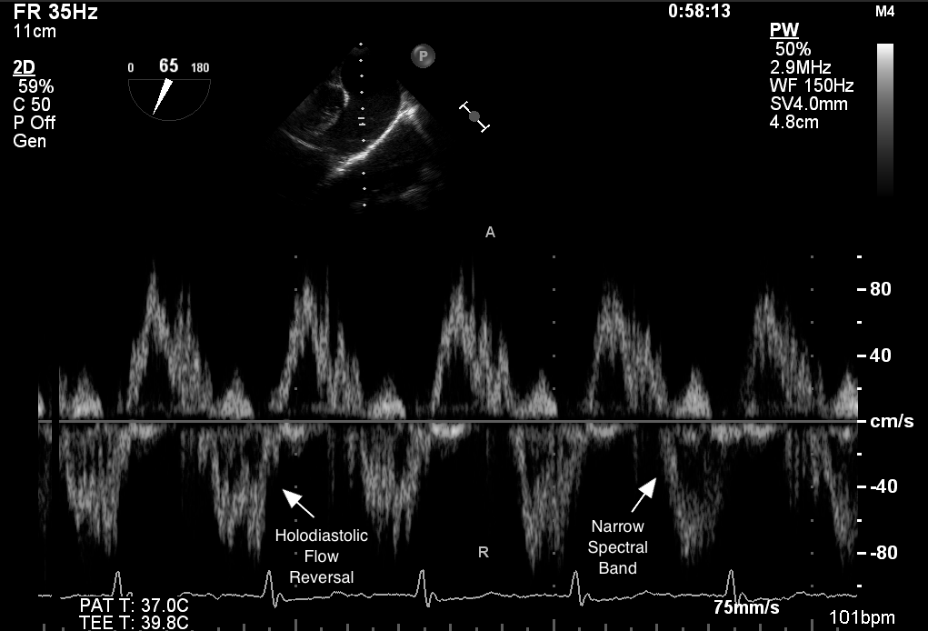 | 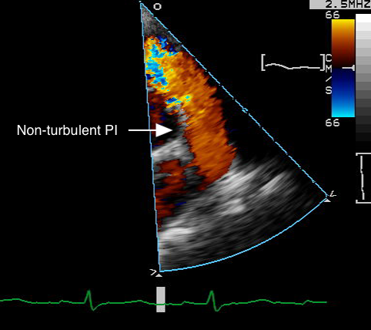
Pulsed-wave Doppler recorded in the pulmonary artery obtained by transesophageal echocardiography shows holodiastolic flow reversal and narrow spectral band of regurgitant flow. | Color Doppler obtained on transthoracic parasternal short axis view at basal level demonstrates severe, hardly turbulent pulmonic insufficiency in early diastole. Note the timing of the frame on EKG tracing.

Figure 3 | Figure 4
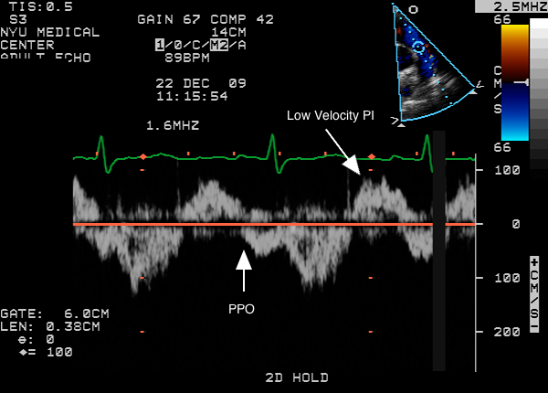 | 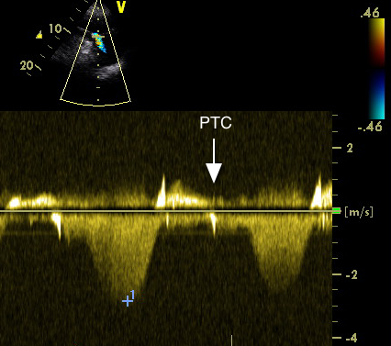
Pulsed-wave Doppler obtained by transthoracic imaging at the pulmonic valve demonstrates low-velocity nonturbulent pulmonic insufficiency and premature pulmonic valve opening (PPO). | Continuous-wave Doppler through the tricuspid valve obtained by transthoracic echocardiography demonstrates premature closure of the tricuspid valve (PTC).

