Simplified Method for Proper Orientation of 3D Transesophageal Images of Atrial Septal Defects: The TUPLE Maneuver
Tatyana A. Danilov, MD; Muhamed Saric, MD, PhD; Gila Perk, MD; Itzhak Kronzon, MD.
New York University Langone Medical Center, New York, NY.

Background

3D transesophageal echocardiography (TEE) is becoming the imaging test of choice for the diagnosis of atrial septal defects (ASD). 3D TEE imaging of ASDs is not standardized and is often nonintuitive. The purpose of the study was to develop a standardized protocol for displaying 3D TEE images of ASDs in a proper anatomic orientation.

Methods

Using a 3D TEE probe, images of ASDs were acquired at a 0° transducer angle in 20 patients and analyzed with online or offline software. The initial 3D image (the so-called ‘opening scene’ depicted in Figure 1A) shows the cranial portion of the atrial septum at the bottom of the screen. We devised a tilt-up-then-left (TUPLE) maneuver using the track ball to first reveal an en face view from the right atrial perspective (Figure 1B). The important landmarks, the superior vena cava (SVC) and the ascending aorta, appear in the long axis. Next, using the track ball the image is tilted to the left around its vertical axis to reveal an en face view of the septum from the left atrial perspective (Figure 1C). Here the superior rim of the septum is on the top and the aortic valve is on the left side of the screen.

Results

ASDs (secundum, n=16; primum, n=3; sinus venosus, n=1) were well visualized in all patients. The TUPLE maneuver allowed for accurate measurement of the size of the ASD and for fast analysis of the spatial relationships between the ASD and the surrounding structures that are important in guiding ASD closure (Figure 2). No ASD was perfectly round; 33% of secundum ASDs showed fenestrations or partial membranes (Figure 3).

Conclusion

For rapid placement of 3D TEE images of the interatrial septum into anatomically correct positions, a simple standardized method consists of image acquisition at 0° followed by the TUPLE maneuver. It facilitates a rapid analysis of ASD relationships to surrounding structures and in percutaneous closure of ASDs.
Figure 1: The TUPLE Maneuver
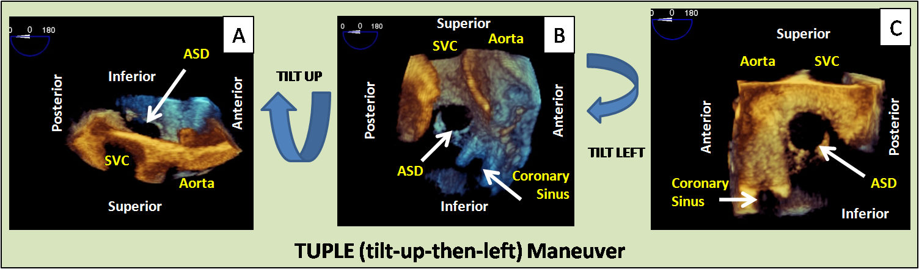
Abbreviations: ASD, secundum atrial septal defect; SVC, superior vena cava.
Figure 2: Rims of Secundum ASD
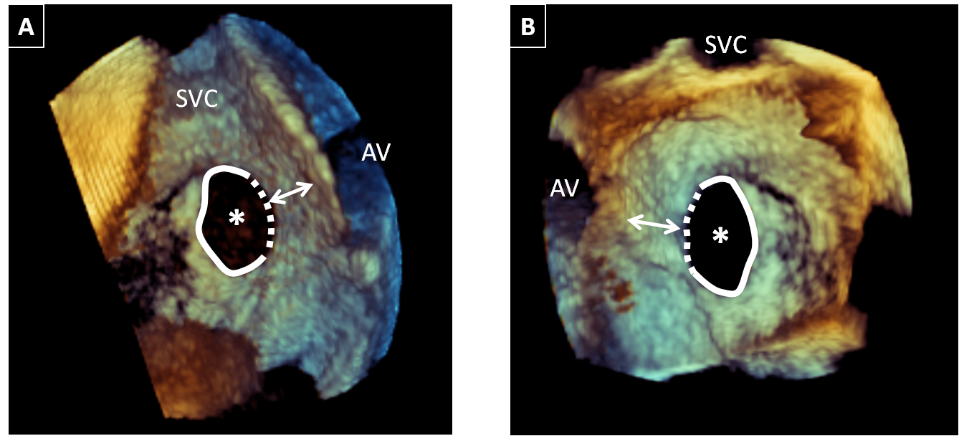
Secundum ASD (*) seen from the right atrial perspective (Panel A) and the left atrial perspective (Panel B). The TUPLE maneuver easily identifies the aortic rim (dotted lines) which is the most important landmark for successful percutaneous ASD closure. The arrows demonstrate the width of the aortic rim tissue. Other ASD rims are represented by the solid lines. Abbreviations: Aortic valve (AV), SVC, superior vena cava.
Figure 3: Partial Membrane of Secundum ASD
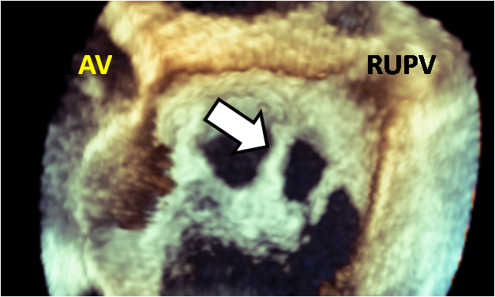 | Secundum ASD seen from the left atrial perspective. The TUPLE maneuver clearly demonstrates the attachment of a partial membrane (arrow) to the superior portion of a secundum ASD. Abbreviations: AV, aortic valve. RUPV, right upper pulmonary vein.

